# SMART CHARGING SYSTEM

Mili Prasad - 2023pcecsmili094@poornima.org,

Kriti Agrawal[-2023pcecskriti083@poornima.org](mailto:-2023pcecskriti083@poornima.org),

Tanvi Khandelwal-2023pcecstanvi172@poornima.org

Akshara Jain - [2023pcecsakshara013@poornima.org](mailto:2023pcecsakshara013@poornima.org)

Department of computer science engineering

Poornima College Of Engineering , Jaipur India

**Abstract-**solve the problemsWireless charging recharges batteries by transferring power to electrical devices across an air gap. The introduction of consumer electronics and the latest advancements in wireless charging methods have created a feasible substitute for the energy limitations of previously transportable battery-operated products. However, there are a number of difficult scheduling, power management, and technological problems that come with combining wireless charging with the current wireless communication technologies.

Because wireless charging is so easy and smooth, it is revolutionizing the way we power our gadgets. The EV battery and the charging station can exchange energy wirelessly thanks to the wireless charging system's usage of inductive power transfer technology. This technique allows for more convenient charging options by doing away

with the requirement for tangled cords. Researchers are trying to related to integrating wireless charging into different gadgets as the demand for it keeps rising. With the use of this technology, users may charge devices more conveniently and effectively since there is no longer a need for cords or plugs. In order to satisfy customer demands and expectations, manufacturers are continuously striving to increase the effectiveness and speed of this cutting-edge technology, which is becoming more and more in demand. Furthermore, to guarantee a flawless user experience, advances in wireless charging technology are particularly concentrated on improving safety features.

# Introduction

"The technology known as wireless charging allows power to be transferred to electrical devices via an air gap. For the purpose of energy replenishment ." a viable way to charge electric vehicles (EVs). It is possible to charge an electric vehicle's (EV) energy storage system without the requirement for physical connections by using magnetic coupling between inductive coils. EV inductive charging is an excellent option due to its many advantages, which include autonomous functioning, protection from severe weather, interoperability, and flexibility. Three approaches are available for the implementation of wireless EV charging: (i) static, in which the EV is charged which is stationary; (ii) dynamic (in motion), in which the EV is charged while it is moving quickly; and (iii) quasi-dynamic, in which the EV is charged while it is moving. Where charging is possible when driving at low speeds or making brief stops. This post presents a thorough analysis of IPT systems in dynamic EV

magnetic substance used in the secondcharging. Based on the electromagnetic resonance concept, resonant=based chargers generate an oscillating electromagnetic field by introducing an oscillating current into a coil. A second coil with the same resonance frequency receives power from the electromagnetic field and converts it into an electrical current that can be used to charge and power devices." To enable wireless charging for electricvehicles, the same magnetic coil found in the charger transfers electricity to a magnetic coil located on the underside of the car. The moment the two pads align, the charging process begins. To accomplish wireless charging, use inductive charging technology. Through electromagnetic induction, portable electronics are powered by this kind of wireless energy transfer. Electromagnetic induction essentially occurs via inductive coupling. It functions as follows:

* An induction coil that receives alternating current (AC) in the charging station creates a magneticfield.
* The strength of this field varies due to the fluctuating amplitude of the electric current.

What Makes Up Coils for Wireless Charging?

Wireless charging basically requires a coil and ferritesetup. A specific-shaped copper coil makes up the first layer. Its primary function is to act as an electromagnetic field antenna. The second layer has a ferrite core that helps focus and guide the magnetic field that the coil produces transmission and reception of wireless energy. Ferrite, alayer, aids in concentrating and directing the magnetic field the coil produces. These parts function as a unit to effectively transfer electricity wirelessly between the device being charged and the charging station. The purpose of wireless charging coils is to generate a magnetic field that facilitates power transfer without requiring physical connections. Effective energy transfer is possible because of the copper coil and ferrite material combination. Additionally, the ferrite material lowers electromagnetic interference and increases the wireless charging process's overall efficiency. Together, the coil and ferrite assembly enable wireless charging. Coils are capable of producing a powerful magnetic field that facilitates efficient power transfer.

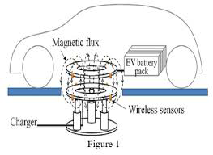

**Future Scope:** In the future, wireless charging systems will prioritize producing bigger power outputs and faster charging speeds. Users will be able to charge their electronic devices—such as cellphones , electric cars, and other gadgets—more quickly as a result. Wireless charging will become even more handy with faster charging speeds, cutting down on wait times.

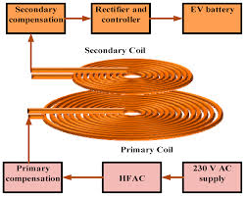

**Resonant Charging*:*** As resonant wireless charging technology advances, longer charging ranges and more flexibility in terms of location will be possible. As a result, charging arrangements will be more adjustable, and devices will be able to charge across greater distances without requiring exact alignment with charging pads. Additionally, the development of charging solutions for larger devices, including laptops and even home appliances, will be facilitated by resonance charging technology. This development will make wireless charging even more ingrained in daily life, increasing customer accessibility and convenience. Resonant charging makes charging more efficient and uncluttered by doing away with the need fornumerous cords and outlets. This concept has the potential to drastically alter how we charge ourelectronics at home, at work, and onthe go.The ability to wirelessly charge larger devices will simplify the charging process for customers by eliminating the need for numerous cords and adapters. The future of wireless power transfer appears bright with resonant charging, opening the door to more effective and convenient charging.

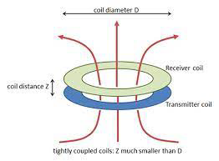

**Outcomes:** The development of wireless charging solutions for electric vehicles hasincreased significantly over the last ten years. By doing away with the need for physical wires and connectors, wireless charging technology makes the convenience billing procedure more user-friendly, practical, and effective. Charging process more convenient, efficient, and user-friendly. In addition, a host of additional advantages make this technology extremely significant later on. By reducing range anxiety and infrastructural constraints, wireless charging has the potential to boost the adoption rates of electric vehicles, which is one of its main benefits. In addition, the market for this invention is anticipated to increase rapidly in the upcoming years as more sectors and products embrace wireless charging technology.

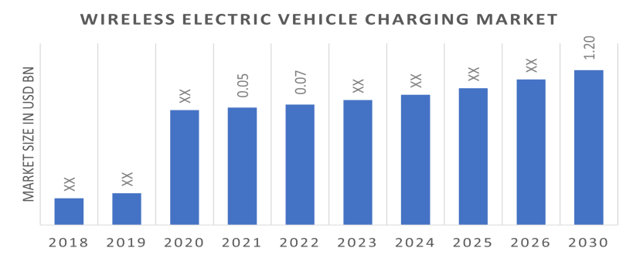

1. Wireless EV charging eliminates the need for physical cables and connectors. Drivers may park their automobiles over charging pads, which is more convenient and user-friendly. The charging process begins automatically.

2. Less Wear and Tear: When there are no physical connections, the EV's charging station and the infrastructure that supports it experience less wear and tear, which may lead to longer lifespans and cheaper maintenance costs.

3. Safety: Since there are no visible cords to trip over or electrical accidents tocause,wireless EV charging is a safer option—especially in public spaces.

Even though they are growing in popularity, wireless electric cars (EVs) are still not as common in the US as they are in Europe and Asia. Commitment will likely accelerate the adoption of wireless EV charging technology in the U.S. Businesses and entrepreneurs in America are holding off on selling EVs until there are enough of them that can be wirelessly charged.

There is now only one EV made in America that has wireless charging as a factory option: the BMW 530¢ hybrid. General Motors appears to be interested in WiTricity, a provider of wireless charging. Siemens invested $25 million in the startup in 2022, and it is presently working on license agreements.

‘This points to a potential shift in the direction of wireless EV charging becoming more widely available in the US market soon. It is anticipated that the use of wireless charging for EVs will rise in America as partnerships and technology continue to progress bringing it closer to the levels observed in Europe and Asia in the financial industry. Wireless EV charging is anticipated to proliferate across the nation as more automakers and charging stations enter the market. Over the projection period of 2023-2029, the Wireless Charging System for Electric Vehicles in India is estimated to develop at a CAGR of %, from USS million in 2022 to USS million by 2022,and In 2020, the wireless charging system market for electric vehicles was estimated to be worth 160.24 million USD; by 2026, itis projected to grow to 1088.47 million USD. We project that global revenue will grow at a CAGR of 36.51% during the next five years. By 2030, it's expected that there will be ‘more than 120 million electric cars on the road, and the infrastructure for charging them will cost ‘more than $50 billion.

In 2020, the market for wireless charging systems for electric vehicles will be dominated by the Americas. Many service providers are present in the area, particularly in the USA, which is once of its defining characteristics. However, throughout the course of the projection period, the APAC area is anticipated to increase at a higher CAGR.

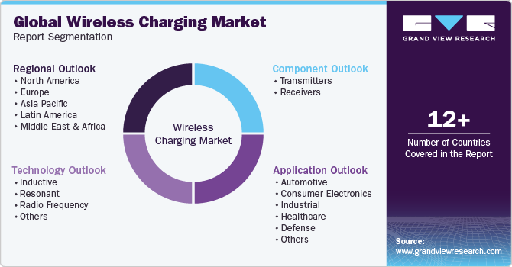

***Conclusion:*** In summary, wireless charging technology is revolutionizing how we power our gadgets by offering a smooth and practical charging experience. Numerous benefits, such asheightened safety, lowered complexity, and cross-industry compatibility, are making wireless charging more and more popular. We may anticipate wireless charging becoming a standard feature in our homes, workplaces, and public areas as the market grows and technology advances.

# References:

* Every article that MDPI publishes is immediately available under an open access license toeverybody in the world. No additional permission is needed to reuse any part or all of the MDPI~published material, including the figures and tables. As long as the original work is correctly ‘mentioned, any part of an article published under an open access Creative Commons CC by license may be reused without obtaining permission Aziz, M., Oda, T., Mitani, T., Watanabe, Y., and Kashiwagi, T.. Utilizing recycled batteries from electric vehicles to shift peak loads (2015).Energies, 8, 3720-3738. For stationary, quasi-dynamic, and dynamic wireless charging publictransportation systems, an initial energy logistics cost analysis is provided. Energy 9, 483 (2016);Jang, Y.1.; Jeong, S.; Lee, M.S. Chen, N.; Chung, S.H.; Chan, L.L.; and Chow, J.P. (2015), 30IEEE Trans. Power Electron., 5632-5649, conducted an examination on the application oforthogonalwinding in weakly coupled connections for improving power transfer efficiency undercoil misalignment.
* Hwang et al. (2019): Autonomous Coil Alignment System Using Fuzzy Steering Control for electric Vehicles with Dynamic Wireless Charging Kwon, J.H.; Park, H.H.; Kim, D.; Ahn,2015, Math. Probl. Eng. 205285 These studies concentrate on enhancing coil alignment and power transfer efficiency in wireless charging systems for electric cars. Fuzzy steering controland orthogonal winding approaches are studied as potential solutions to problems such as coil‘misalignment. These studies concentrate on enhancing coil alignment and power transferefficiency in wireless charging systems for electric cars steering control and orthogonalwinding techniques are investigated as potential solutions for problems such as coilmisalignment. These studies concentrate on enhancing; coil alignment and power transferefficiency in wireless charging systems for electric cars. Fuzzy steering control and orthogonalwinding are two creative solutions for problems like coil misalignment anddynamic charging.